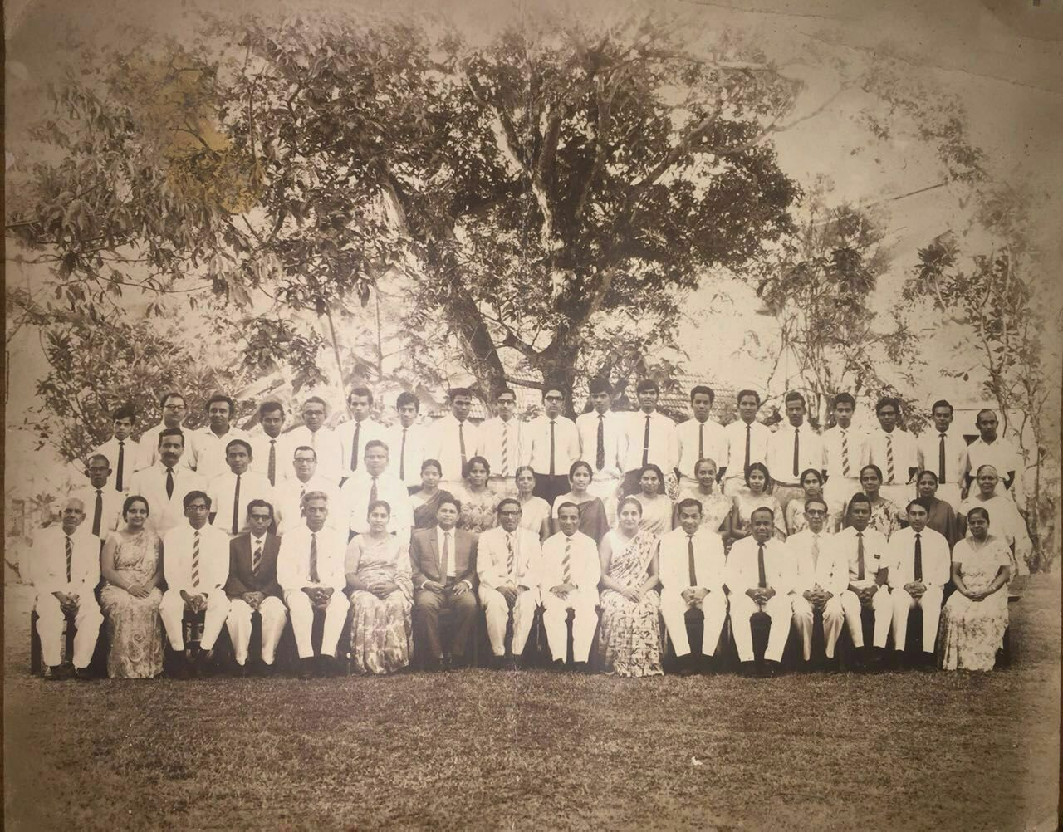

Please complete all those in red and ?

**SEATED (L-R):** VR ROBERTS, ANGELA FERNANDO, AFGHAR MOHIDEEN, MR GUNARATNAM, MR SIVALINGAM **or is it** MR SIVAPRAGASAM, MRS AMERATUNGE, JOHN VETHANAYGAM, AS WIRASINHA, CHARLES DE SILVA, MRS ENID SIVASUBRAMANIAM, WILFRED WICKRAMASINGHE,MR SUNDERALINGHAM, ERIC DE SILVA, JUSTIN DE SILVA, MAP FERNANDO, MRS SEG PERERA

**SECOND ROW (L-R):** WADUWA’S ASSISTANT**?,** FELIX PREMAWARDHENA, DA PAKIANATHAN, EDMUND DISSANAYKE, **?, ?**, MISS MASSILAMONI, MRS VERNON FERNANDO, MRS MARY GNANIAH, DULCIE DE MEL, MISS NORMA DE SILVA, MS DULCIE DE ALWIS, MRS ISLA PERERA, MRS LEENA DE SILVA (PAPAW SEED), MRS STEMBO

**BACK ROW(L-R):** MR WICKREMASINGHE,MR CHANDRASEKARAM(AL Physics),HAIG KARUNARATNE, MR THAMBIAH (Tamil Maths & Physics), **?,?, ?,** ROHAN SOYSA,MR THURAIRATNAM (Mechanical drawing), **?,** MR PATTERNOT?, NIMAL DE SILVA, A K SUPPIAH , MR SIVANAYAGAM, PGR FERNANDO, M U De SKALUPAHANA, MR PREMEDASA, PRASSAN WIJESINGHE, MR KARUNARATNE

**TEACHERS MISSING FROM PHOTO ARE**

MRS SHEILA WIJEYEKOON

MR RAJU HENSMAN

MR DHARMARATNE (WADUWA)

MR EL RODRIGO (BOOKSHOP AND SCOUTS/CUBS)

MR L C R WIJEYESINGHE

MR MARSHALL FERNANDO

MR BASIL MIHIRIPANNE (SINHALA CLASSICAL DANCE)

MR P I PERERA